8. Software Design Approach
The Student Record Management System was developed using the Waterfall Software Development Life Cycle (SDLC). This approach was chosen because the project requirements were already known before development started. The Waterfall model allowed the team to complete the project step by step from planning to implementation.
The first stage was requirements analysis. During this stage, the team studied the project brief and identified the functions that the system needed to perform. These included managing student records, controlling user access, handling module registrations and processing grades. The system was designed to support different users such as Administrators, Lecturers and Authorities.
The second stage was system design. The team created pseudocode and a UML class diagram to provide a clear understanding of how the system would operate. The design helped identify the main classes and relationships within the system before coding started.
The third stage was implementation. The system was developed using Java and Object-Oriented Programming principles. Constructors, methods, modifiers and control structures were used to implement the required functionality. Java JFrame Forms were used to create the graphical user interface.
The fourth stage was testing. Functions such as login, student registration, student searches and grade updates were tested to ensure that they worked correctly. Input validation and error handling were also tested.
The final stage involved documentation and preparing the application for presentation. The Waterfall approach helped the team remain organised throughout development.

9. Engineering Method (SDLC)
The project followed a structured engineering method to solve the problem of managing student records manually. Manual record keeping can be slow and can lead to errors. The aim of the system was to provide a digital solution for managing student information more efficiently.
The first step was identifying the problem and analysing the project requirements. The team examined the project brief and determined the features that the system needed to provide, including authentication, student management, registration and grade management.
The second step was planning and design. UML diagrams and pseudocode were developed before coding. This helped the team understand the structure and flow of the application.
The third step was development. The application was implemented in Java using different classes that work together to perform system functions. Classes such as Student, User, Course, Subject, Enrolment and DataStore were used to organise the system.
The fourth step was testing and evaluation. The system was tested to verify that users could access the required functions and manage student data successfully.
The final step was documentation. The development process, UML diagram and pseudocode were documented as part of the technical report. Following this engineering method helped the team develop a system that satisfies the project requirements.

10. Skills used
Several technical and professional skills were used during the development of the Student Record Management System.
Programming skills were required to develop the application in Java and implement system functions such as authentication, student management and enrolment management.
Object-Oriented Programming skills were used through the application of classes, objects, constructors, methods and access modifiers. These concepts helped improve the organisation and maintainability of the code.
Problem-solving skills were important when debugging errors and implementing solutions to meet the project requirements. Logical thinking was also used when developing algorithms and validation procedures.
Teamwork skills played an important role because responsibilities were shared among group members. Some members focused on development while others focused on documentation and reporting.
Communication skills were required during discussions, planning sessions and project updates. Technical writing skills were also used to prepare the technical report, pseudocode and UML documentation.

11. Tools used
Several tools were used during the development of the Student Record Management System.
Apache NetBeans IDE was used to write, compile, debug and test the Java source code.
Java Development Kit (JDK) was used to compile and run the Java application.
Java JFrame Forms were used to create the graphical user interface, allowing users to interact easily with the system.
GitHub was used for version control and contribution management. Team members uploaded their work, monitored project progress and maintained different versions of the project using the repository.
UML modelling tools were used to design the UML class diagram during the planning stage.
Microsoft Word was used to prepare and format the technical report.
These tools helped improve collaboration, organisation and the overall quality of the project.

12. Pseudocode
The complete pseudocode for the Student Record Management System is provided in Appendix A.
The pseudocode was developed during the design phase and served as a guide before implementation. It describes the major classes and functions of the system, including user authentication, student management, registration, grade processing and compliance auditing. The pseudocode helped ensure that the logic of the system was clearly defined before coding began.

13. UML Diagram
The UML Class Diagram was developed during the design phase to provide a visual representation of the structure of the Student Record Management System. The diagram shows the relationships between users, students, courses, subjects, enrolments and the central DataStore class.
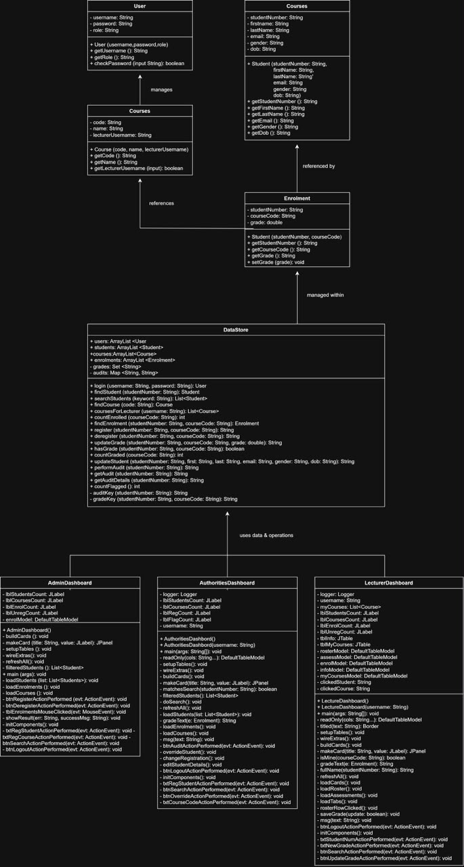

The UML diagram helped the team understand how different classes interact within the application. It also served as a blueprint during implementation by showing class relationships, attributes and methods. The diagram demonstrates the use of Object-Oriented Programming principles and helped improve the overall design of the system.

